Mapping the current knowledge in syndemic research applied to Men who have Sex with Men : a Scoping Review

Maxence R. Ouafik1, Laetitia Buret2, Jean-Luc Belche3, Beatrice Scholtes4

1 Corresponding author at : General Practice Department - Primary Care and Health Research Unit, MD - PhD student, University of Liège, Liège, Belgium [maxence.ouafik@uliege.be](mailto:maxence.ouafik@uliege.be) ; Quartier Hôpital B23 Avenue Hippocrate 13 4000 Liège OrcID <https://orcid.org/0000-0002-9795-5721>

2 General Practice Department - Primary Care and Health Research Unit, MD - GP - PhD, research assistant, University of Liège, Liège, Belgium [laetitia.buret@uliege.be](mailto:laetitia.buret@uliege.be) OrcID <https://orcid.org/0000-0001-6039-9824>

3 General Practice Department - Primary Care and Health Research Unit, MD - GP - PhD, lecturer, University of Liège, Liège, Belgium [jlbelche@uliege.be](mailto:jlbelche@uliege.be) OrcID <https://orcid.org/0000-0001-8807-0473>

4 General Practice Department - Primary Care and Health Research Unit, Postdoctoral Researcher, University of Liège, Liège, Belgium [beatrice.scholtes@uliege.be](mailto:beatrice.scholtes@uliege.be) OrcID <https://orcid.org/0000-0001-5274-822X>

# 1 Results

### 1.2.2 Subpopulations studied

A bit less than half of the studies (N = 48 ) focus on a subpopulation of MSM. In this review, we identified 6 kind of MSM subpopulations studied in syndemic literature : (a) young MSM and older MSM ; (b) MSM from a racial/ethnic minority ; (c) MSM living with HIV ; (d) MSM engaged in sex work ; (e) Men who have Sex with Men and Women (MSMW) ; and (f) transgender MSM.

Among studies focusing on a specific age group, 12 studies focus on young adults, 2 studies focus on older MSM[3,4] and 1 study focuses on adolescents[5]. Of note, the two studies on older MSM are both entirely composed of a sample of older MSM living with HIV.

Black MSM (BMSM) are the most studied MSM from a racial/ethnic minority (N= 14) but studies focusing on them still represent only 13% of our sample. Among these studies, 2 studies are composed of young BMSM[6,7] and 1 study focuses on Black MSM engaged in sex work[8].  
Only (N= 7) studies focus on Latino MSM (LMSM) and 1 of these studies focus on Latino MSMW[9]. Furthermore, 1 study focus on both BMSM and LMSM[10].

Concerning the serologic status of MSM in syndemic literature, 13 studies are entirely comprised of a sample of MSM living with HIV. Apart from the aforementioned studies on older MSM living with HIV, 2 studies focus on young MSM living with HIV[11,12] . Notably, we identified no studies conducted on racial minority MSM living with HIV.

Finally, the least represented subpopulation of MSM in this review are MSMW (N = 2), MSM engaged in sex work (N = 2) and transgender MSM (N = 1). Strikingly, transgender MSM, in addition to being the focus of only one study[13] are, by design, excluded from every other study whereas other MSM subpopulation are at least partially represented in most of the samples.

Figure 1.3 gives a visual representation of MSM subpopulation’s representation in the studies included in this paper.

In order to have the most comprehensive knowledge of the representation of MSM subpopulations in syndemic literature, we also measured took into account studies who did not focus on any subpopulation in particular but who presented disaggregated data and analyses for one or more MSM subpopulation.  
8 studies presented such data : 1 for Black MSMW[14], 4 for MSMW[15–18], 2 for MSM living with HIV[19,20] and 1 for Latino and Black MSM[21].

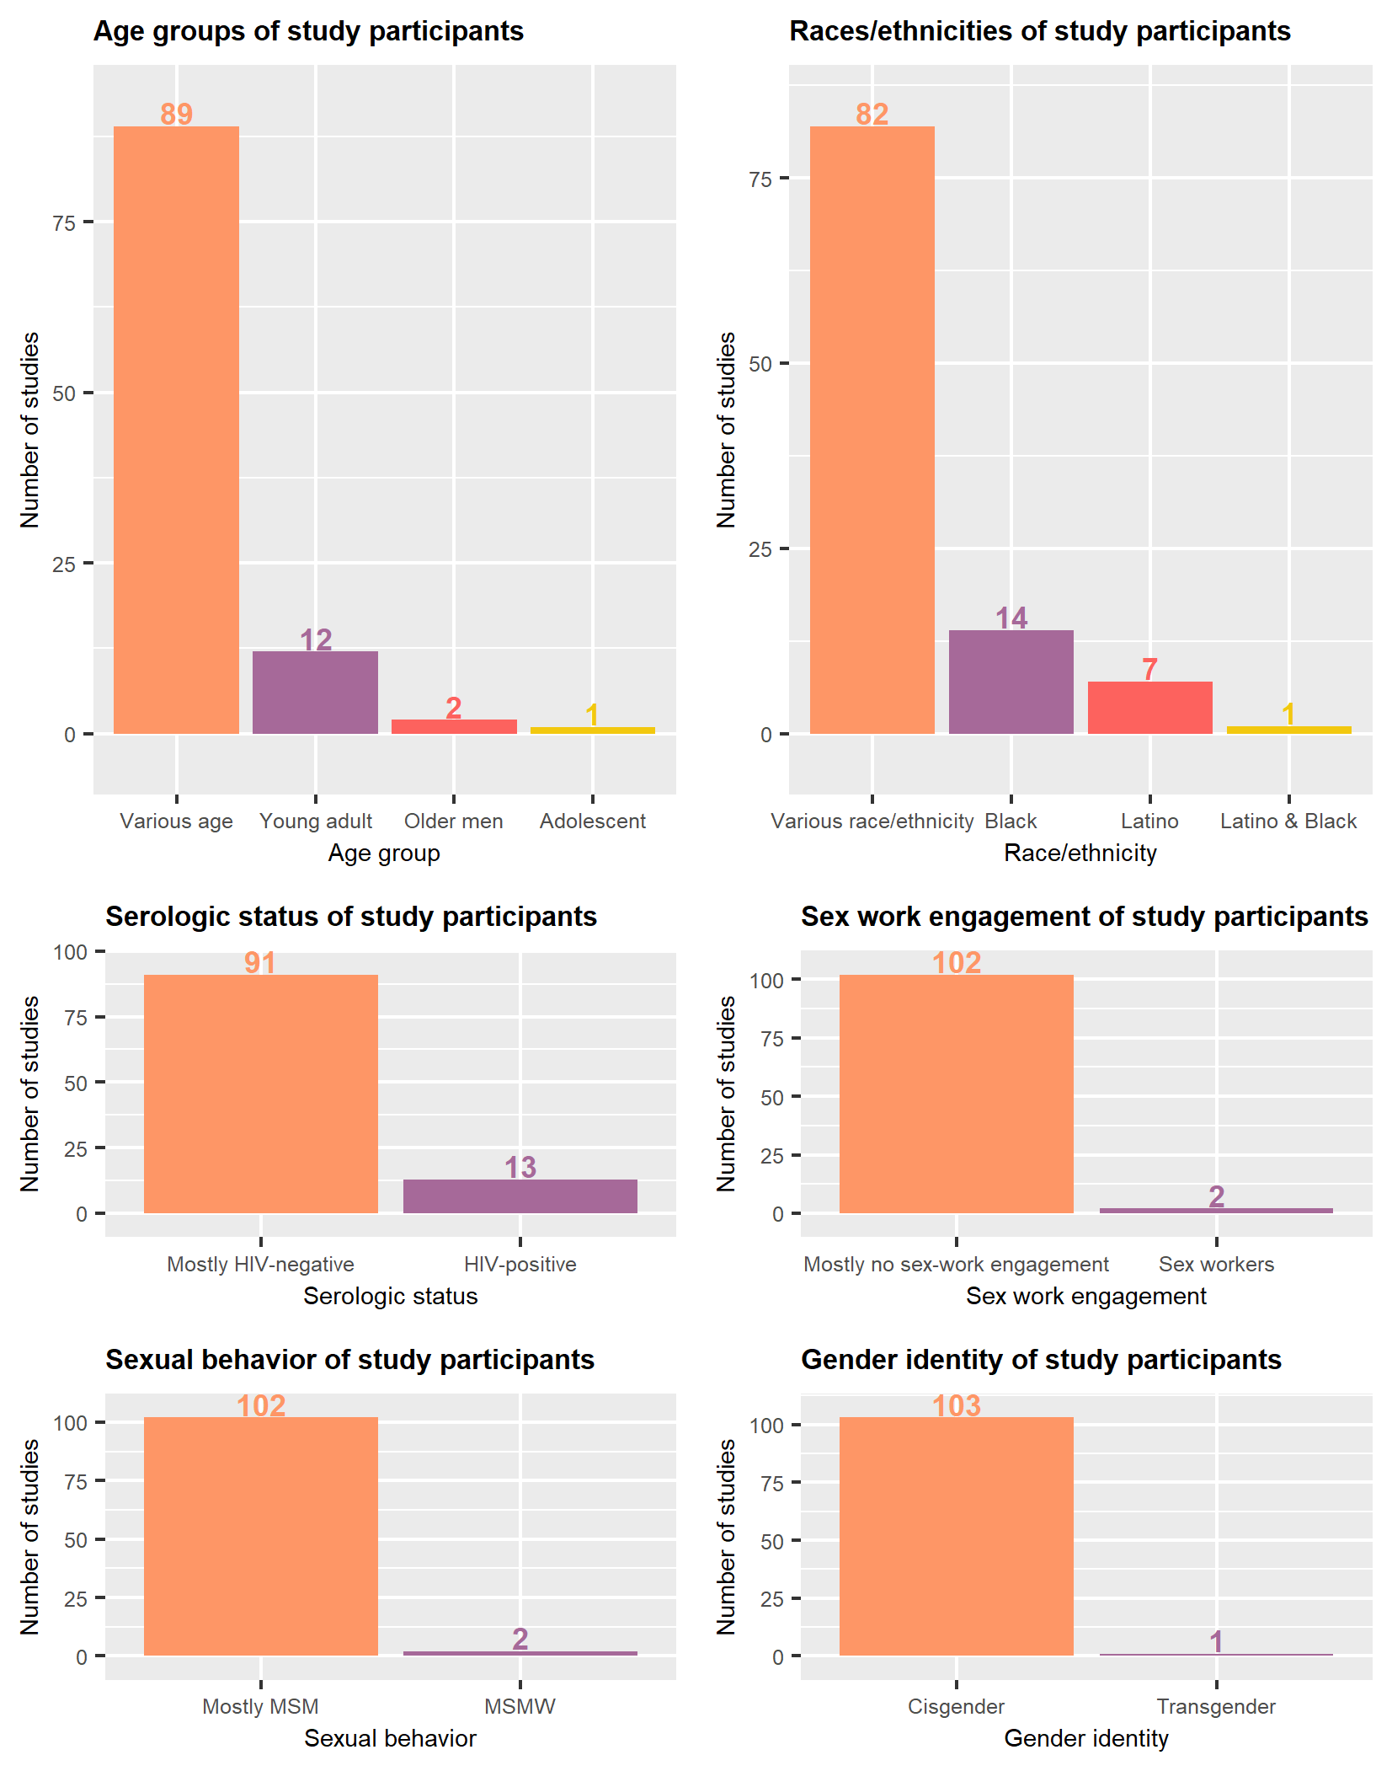

Figure 1.3: Number of studies focusing on a MSM subpopulation, by kind of subpopulation

# 4 References

1 Stall R, Mills TC, Williamson J, *et al.* Association of co-occurring psychosocial health problems and increased vulnerability to HIV/AIDS among urban men who have sex with men. *American Journal of Public Health* 2003;**93**:939–42. doi:[10.2105/AJPH.93.6.939](https://doi.org/10.2105/AJPH.93.6.939)

2 Buttram ME, Kurtz SP. A mixed methods study of health and social disparities among substance-using african american/black men who have sex with men. *Journal of Racial and Ethnic Health Disparities* 2015;**2**:1–0. doi:[10.1007/s40615-014-0042-2](https://doi.org/10.1007/s40615-014-0042-2)

3 Zepf R, Greene M, Hessol NA, *et al.* Syndemic conditions and medication adherence in older men living with HIV who have sex with men. *AIDS Care* 2020;**32**:1610–6. doi:[10.1080/09540121.2020.1772954](https://doi.org/10.1080/09540121.2020.1772954)

4 Halkitis PN, Kupprat SA, Hampton MB, *et al.* Evidence for a Syndemic in Aging HIV-positive Gay, Bisexual, and Other MSM: Implications for a Holistic Approach to Prevention and Healthcare. *Annals of anthropological practice* 2012;**36**:365–86. doi:[10.1111/napa.12009](https://doi.org/10.1111/napa.12009)

5 Perry NS, Nelson KM, Carey MP. Diversity of psychosocial syndemic indicators and associations with sexual behavior with male and female partners among early adolescent sexual minority males. *LGBT Health* 2019;**6**:386–92. doi:[10.1089/lgbt.2019.0113](https://doi.org/10.1089/lgbt.2019.0113)

6 Maiorana A, Kegeles SM, Brown S, *et al.* Substance use, intimate partner violence, history of incarceration and vulnerability to HIV among young black men who have sex with men in a southern US city. *Culture, health & sexuality* Published Online First: 2020. doi:[10.1080/13691058.2019.1688395](https://doi.org/10.1080/13691058.2019.1688395)

7 Reed SJ, Miller RL. Thriving and Adapting: Resilience, Sense of Community, and Syndemics among Young Black Gay and Bisexual Men. *American journal of community psychology* 2016;**57**:129–43. doi:[10.1002/ajcp.12028](https://doi.org/10.1002/ajcp.12028)

8 Chandler CJ, Meunier E, Eaton LA, *et al.* Syndemic health disparities and sexually transmitted infection burden among black men who have sex with men engaged in sex work in the u.s. *Archives of Sexual Behavior* Published Online First: 2020. doi:[10.1007/s10508-020-01828-2](https://doi.org/10.1007/s10508-020-01828-2)

9 Muñoz-Laboy M, Martinez O, Levine EC, *et al.* Syndemic Conditions Reinforcing Disparities in HIV and Other STIs in an Urban Sample of Behaviorally Bisexual Latino Men. *Journal of immigrant and minority health* 2018;**20**:497–501. doi:[10.1007/s10903-017-0568-6](https://doi.org/10.1007/s10903-017-0568-6)

10 Cassels S, Meltzer D, Loustalot C, *et al.* Geographic mobility, place attachment, and the changing geography of sex among african american and latinx MSM who use substances in los angeles. *Journal of urban health : bulletin of the New York Academy of Medicine* 2020;**97**:609–22. doi:[10.1007/s11524-020-00481-3](https://doi.org/10.1007/s11524-020-00481-3)

11 Lyons T, Johnson AK, Garofalo R. "What Could Have Been Different": A Qualitative Study of Syndemic Theory and HIV Prevention among Young Men Who Have Sex with Men. *Journal of HIV/AIDS & Social Services* 2013;**12**:368–83. doi:[10.1080/15381501.2013.816211](https://doi.org/10.1080/15381501.2013.816211)

12 Bruce D, Harper GW, Interventions AMTN for H. Operating without a safety net: gay male adolescents and emerging adults’ experiences of marginalization and migration, and implications for theory of syndemic production of health disparities. *Health Education & Behavior* 2011;**38**:367–78. doi:[10.1177/1090198110375911](https://doi.org/10.1177/1090198110375911)

13 Reisner SL, White Hughto JM, Pardee D, *et al.* Syndemics and gender affirmation: HIV sexual risk in female-to-male trans masculine adults reporting sexual contact with cisgender males. *International Journal of STD & AIDS* 2016;**27**:955–66. doi:[10.1177/0956462415602418](https://doi.org/10.1177/0956462415602418)

14 Dyer TV, Turpin RE, Stall R, *et al.* Latent profile analysis of a syndemic of vulnerability factors on incident sexually transmitted infection in a cohort of black men who have sex with men only and black men who have sex with men and women in the HIV prevention trials network 061 study. *Sexually transmitted diseases* 2020;**47**:571–9. doi:[10.1097/OLQ.0000000000001208](https://doi.org/10.1097/OLQ.0000000000001208)

15 Branstrom R, Pachankis JE. Sexual orientation disparities in the co-occurrence of substance use and psychological distress: A national population-based study (2008-2015). *Social psychiatry and psychiatric epidemiology*;403. doi:[10.1007/s00127-018-1491-4](https://doi.org/10.1007/s00127-018-1491-4)

16 Mustanski B, Andrews R, Herrick A, *et al.* A syndemic of psychosocial health disparities and associations with risk for attempting suicide among young sexual minority men. *American Journal of Public Health* 2014;**104**:287–94. doi:[10.2105/AJPH.2013.301744](https://doi.org/10.2105/AJPH.2013.301744)

17 Friedman MR, Kurtz SP, Buttram ME, *et al.* HIV risk among substance-using men who have sex with men and women (MSMW): Findings from south florida. *AIDS and Behavior* 2014;111–9. doi:[10.1007/s10461-013-0495-z](https://doi.org/10.1007/s10461-013-0495-z)

18 Ferlatte O, Salway T, Trussler T, *et al.* Combining intersectionality and syndemic theory to advance understandings of health inequities among canadian gay, bisexual and other men who have sex with men. *Critical Public Health* 2018;**28**:509–21. doi:[10.1080/09581596.2017.1380298](https://doi.org/10.1080/09581596.2017.1380298)

19 Kurtz SP, Buttram ME, Surratt HL, *et al.* Resilience, syndemic factors, and serosorting behaviors among HIV-positive and HIV-negative substance-using MSM. *AIDS Education and Prevention* 2012;**24**:193–205. doi:[10.1521/aeap.2012.24.3.193](https://doi.org/10.1521/aeap.2012.24.3.193)

20 Ng RX, Guadamuz TE, Akbar M, *et al.* Association of co-occurring psychosocial health conditions and HIV infection among MSM in malaysia: Implication of a syndemic effect. *International Journal of STD & AIDS* 2020;**31**:568–78. doi:[10.1177/0956462420913444](https://doi.org/10.1177/0956462420913444)

21 Mustanski B, Phillips G, Ryan DT, *et al.* Prospective effects of a syndemic on HIV and STI incidence and risk behaviors in a cohort of young men who have sex with men. *AIDS and Behavior* 2017;**21**:845–57. doi:[10.1007/s10461-016-1607-3](https://doi.org/10.1007/s10461-016-1607-3)